Order Of Lenten Service

Opening Hymn: TLH 142

Reading: Lent II

The History of the Passion of our Lord

Sermon Hymn: TLH 436

Sermon Text: Song Of Solomon 5:14b

His Heart

Prayer

Holy Communion

The Lord's Prayer

The Blessing

Closing Hymn: TLH 145

* * * * * * * * * * * * *

Koinonia Hour



David Protecting Sheep

Water
Of
Life

5 March 2017

W A T E R O F L I F E

Independent Christian Church—Conservative Lutheran Doctrine

Worship Service: 9:30 a.m. Bible Study: 10:45 a.m.

Larry Cooper, Pastor E-Mail address:
111 N. Ridge Road lcooper@wateroflife.cc
Coon Valley, WI 54623 Web Site:
Phone: (608) 452-2105 www.wateroflife.cc

* * * * * * * * * * * * * * * * * * * * * * * * * * *

Sermon Text: Song Of Solomon 5:14b

His Heart

* * * * * * * * * * * * * * * * * * * * * * * * * * *

5:14b his belly is as bright ivory overlaid with sapphires.

Related Passages:

I Samuel 17:34-37

34 And David said unto Saul, Thy servant kept his father's sheep, and there came a lion, and a bear, and took a lamb out of the flock:
35 And I went out after him, and smote him, and delivered it out of his mouth: and when he arose against me, I caught him by his beard, and smote him, and slew him.

36 Thy servant slew both the lion and the bear: and this uncircumcised Philistine shall be as one of them, seeing he hath defied the armies of the living God.

37 David said moreover, The LORD that delivered me out of the paw of the lion, and out of the paw of the bear, he will deliver me out of the hand of this Philistine. And Saul said unto David, Go, and the LORD be with thee.

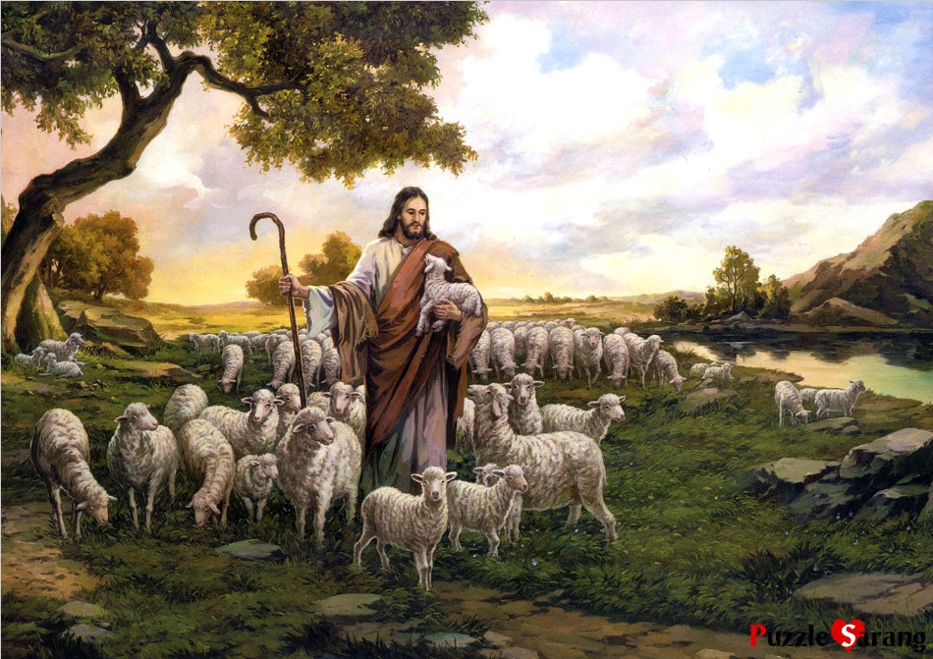

John 10:11-14

11 I am the good shepherd: the good shepherd giveth his life for the sheep.
12 But he that is an hireling, and not the shepherd, whose own the sheep are not, seeth the wolf coming, and leaveth the sheep, and fleeth: and the wolf catcheth them, and scattereth the sheep.
13 The hireling fleeth, because he is an hireling, and careth not for the sheep.
14 I am the good shepherd, and know my sheep, and am known of mine.

